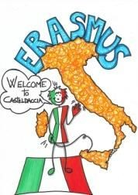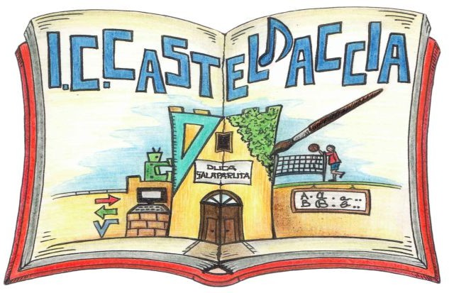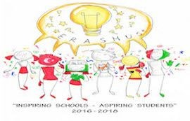

I.C. Casteldaccia

Students council's programme for the school year 2017/2018

The aims of a students' council:
- represent the student body
- advocate on behalf of students and protect their rights
- encourage and promote independence in solving students' problems
- co-operate with schools' management and staff on the development of school rules and regulations
- help to develop democratic forms of coexistence, co-operation of students and accepting a joint responsibility for an individual and a group
- promote teamwork, self-control, self-evaluation and discipline of students
- uphold school's honour and reputation, cultivate and enrich its tradition

Time | Tasks | Who’s responsible | Who helps to organize the event/do the task
SEPTEMBER | - Introducing of the class representatives to the entry classes.  - The introduction of class representatives during a school assembly. | Erasmus group teachers | Class representatives

OCTOBER | - Elections of classes representatives (only first classes)  - Class representatives meet to individualize the candidates who want to take part in the campaign for the next President.  - Celebration of the World Food Day  - Election of the School Parliament President.  - Code week activity  - Drawing up of the activities to be approved for the whole year.  - Pen Friends: starting writing traditional letters | Erasmus group Teachers  Classes with their form teachers | Class representatives
NOVEMBER | - November 2017  - Short term students exchange: Festival of the school parliament’s activities.  - Last week of November 2017- Tournament of volleyball teachers versus students.  - the meeting of the students council with the school's head teacher | Erasmus group teachers | Class representatives

DECEMBER | - 18 December - International migrants’ day -awareness raising initiatives in the classes and folk show in order to involve the Nigerian students.  - Week sharing: report of the activities done.  - Christmas activities: a recital of Christmas songs, a poster with Christmas wishes to the staff, teachers and students of our school.  - Starting to organize the “Inspirational Travel” | Erasmus group Teachers | Class representatives
JANUARY | - The Italian Constitution was introduced 70 years ago: reflection on its importance.  - 27 January  - The Memorial day - a series of activities will be realized to commemorate the Shoah.  - Grandparents’ day - playing games together. Exchange games among the partner schools. | Erasmus group Teachers | Class representatives
FEBRUARY | - Carnival activities : let’s have a Carnival party!  - “How to be Van Gogh” - students draw, paint, photograph works inspired by a national artist. A local artist ( painter/ musician/ folk craftsman) visits the school and runs a workshop during which they learn new art techniques.  - Musical chorus performance (all the students dress in red) | Erasmus group  Teachers | Class representatives

MARCH | - The traditional table of Saint Giuseppe.  - Short term SS exchange in Bulgaria “We are active and creative” (exchanging of brochures and recipes and presentation of the school parliament’s work)  - Celebration of the birth of the Italian Unification: 17 March | Classes with their form teachers | Class representatives
APRIL | - Prepare a poster with Easter wishes to the staff, teachers and students of our school  - 27 April - World Drawing day: A competition during which students make a drawing about a particular topic: (peace, integration..) The best drawings will be displayed and rewarded.  - The school trip organized by the students. | Erasmus group  teachers | Class representatives
MAY | - “Ecologicamente Miro”  Students recreate some of Miro’ paintings using recycled materials.  - Visit of the local city hall | Erasmus group  teachers | Class representatives
JUNE | - The celebration of the end of the school year 2017/2018  - Teachers ‘ meeting in Turkey | Erasmus teachers | Class representatives

