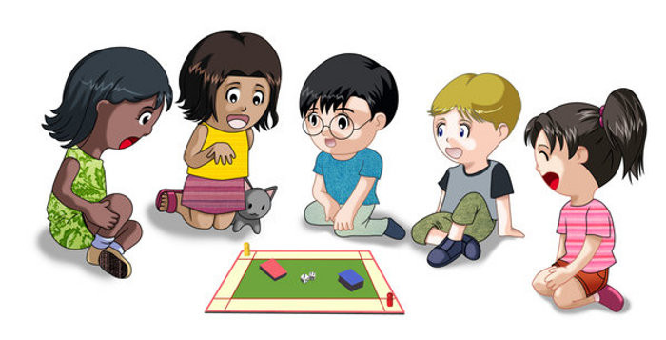

For each child school is a place of knowledge and unforgettable moments.I will tell you some of my funniest ones which happened at school!
Imagine three little girls,students in first grade playing alone in a room,without a teacher.As a madhouse,isn’t it?I was nibbling a sweet apple and I got “the great idea” to hit trash across the room.I threw it but it never fall.I looked up-it was jammed on a lamp.
Next day when our class teacher switched on the lights,one of the lamps shone with a greenish tint.She looked surprised when she saw the apple and called the school guard to strip it off.
And do you believe that a teacher can become a mother to more than twenty students??!!!!! Mine was,because she was a teacher in my school and she was my teacher in first grade,she taught me !
I called her Mum even at school and my parents reminded me constantly that at school I had to call her ,,Teacher”.I ALWAYS forget.:))))))))))))!Imagine how difficult it is for a 7 years old child to call his/hers Mum –Teacher!
So my classmates started to call her Mom instead of Teacher and she got a lot of children.
Оnce we’d sleep in school.Boys and girls in my class,me as well stayed after normal classes to play ,,Blind man’s buff”.So engrossed in the game,we didn’t feel the time passing and suddenly my phone rang-Dad was calling.It turned out that it had become quite late!Descending downstairs,we saw that our school cleaner was just locking the school.:))))I don’t know what would have happened if my Dad hadn’t rung me.

Stanimira Nacheva-7th grade

