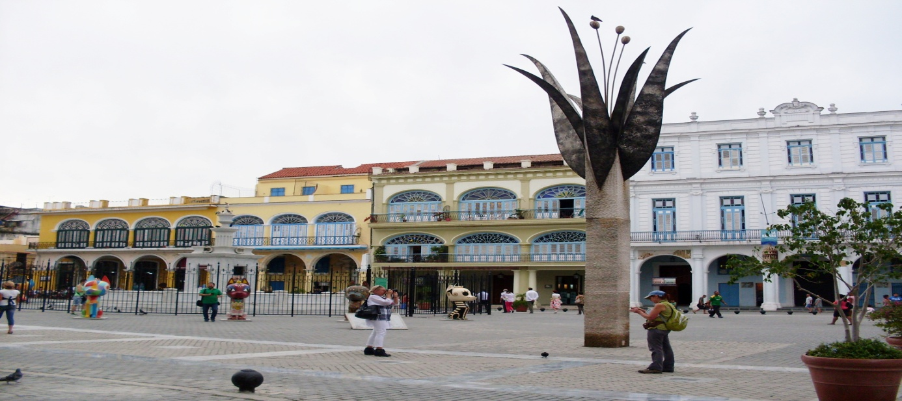

My unforgettable week in Dos Hermanas/Stanimira Nacheva/

1.I was surprised of people who were having sunbathe in the park lying on the grass.
2.I liked so much people there-all were happy,relaxed and so friendly.
3.I will never forget Lucia and her family.I miss them so much.
4.In the school I met new friends and I had a lot of fun with them.
5.In the evenings I was in Seville and I visited different places.
6.I was happy when we arrived in Dos Hermanas and met my host family.
7.I didn’t like the traffic there.

