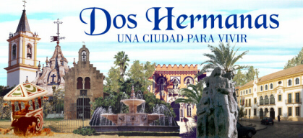I

My week in Dos Hermanas/Kristian Ivanov/
1.I was surpised of the respect to me of host family and my Spanish school mates.

2.I liked the condition of the roads, the cars, the cities, the parks and the houses.

3.I will never forget the family, the nice weather, the beautiful places in Spain.

4.In the school I watched movies, listened to music,drew paintings and played games.

5.In the evenings I went to other towns and sightseeing.

6.I was happy when I went for a walk with the host hamily.

7.I don’t like the food.

