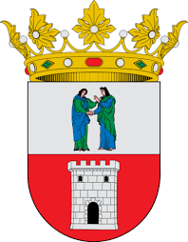

My life in Dos Hermans/Alkin Nergin/

- I was surprised when the family gave me a
T-Shirt as a present.

- I liked my classmates, they were very friendly.

- I will never forget the family, the teachers, the school and my Spanish friends.

- In the school I was listening carefully to the teachers.

- In the evenings I played with Dario on his game console.

- I was happy when we went to a football match.

- I didn't like the traffic in Madrid.

